**Technical Documentation – Release_ONLINE_BATCH_Forms_Reports_to_IPASP**

1. Workflow – Releases FAR Environments from the MUAT/MAINT environment to IPASP/Production.

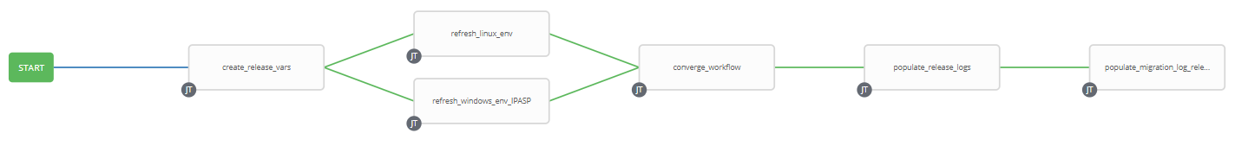

1. Extra Variables Defined at the Workflow Level

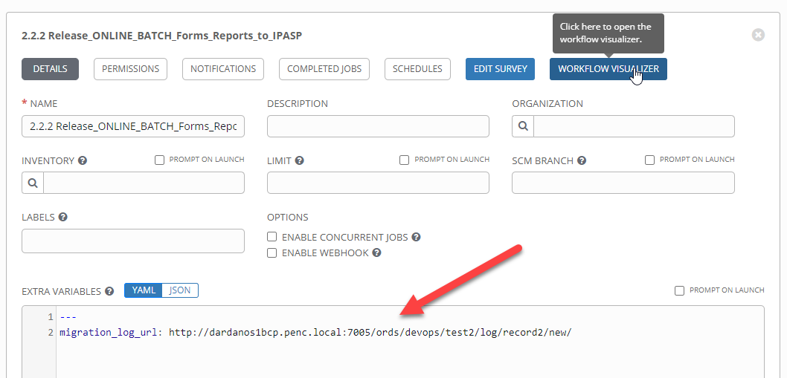

1. Survey – User Supplied Variables

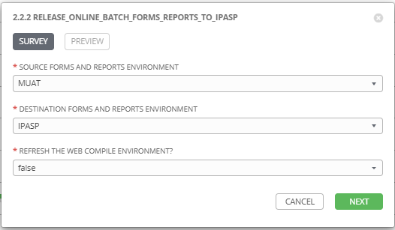

|  |  |  |  |
| --- | --- | --- | --- |
| **Survey Extra Variables** | **Prompt** | **Type** | **Description and Usage** |
| SOURCE | Source Forms and Reports Environment | Multiple Choice Single Pick | Environment to copy FAR Artifacts FROM (MUAT). |
| DESTINATION | Destination Forms and Reports Environment | Multiple Choice Single Pick | Environment to copy FAR Artifacts TO (IPASP is all that is allowed). |
| REFRESH_WEB | Refresh the Web COMPILE Environments | Multiple Choice Single Pick | true or false (default is false). If this is set to true the WEB Compile environment will be released. |

1. Jobs Used by the workflow - http://owl.penc.local:18080/svn/deploy_automation/trunk/Ansible_PlayBooks/FAR

| **Job Template** | **Ansible Playbook** | **Credentials / host** | **Project** | **Description and Usage** |
| --- | --- | --- | --- | --- |
| create_release_env_vars | create_release_env_vars.yml | None – runs on localhost as awx linux user | FAR Deployments | Destination_Batch_Compile_Directory: \\cronrepprod\Reports$\defs\ipasp  Destination_Online_Compile_Directory: /export_home/codemove/compile/ipas12c/ipasp  Destination_Online_Runtime_Directory: /opt/ipas_app/ipasp  Destination_WEB_Compile_Directory: /export_home/codemove/compile/ipas12c/webp  Source_Batch_Compile_Directory: \\cronrepmaint\Reports$\defs\muat  Source_Online_Compile_Directory: /export_home/codemove/compile/ipas12c/muat  Source_Online_Runtime_Directory: /opt/ipas_app_test/muat  Source_WEB_Compile_Directory: /export_home/codemove/compile/ipas12c/webm  batch_far_server: cronrepprod  date_time: '20200730_1713'  far_server: taras1bcp  open_chmod: false  stage_server: daulis1bcp  tower_hostname: pdeploy1bcp.penc.local |
| refresh_linux_env | refresh_linux_env.yml | Codemove on {{far_server}} typically taras1bcp | FAR Deployments | Backs up the {{Destination_Online_Compile_Directory}}, {{Destination_Online_Runtime_Directory}} and {{Destination_WEB_Compile_Directory}} Directories and then copies the {{Source_Online_Compile_Directory}}, {{Source_Online_Runtime_Directory}} and {{Source_WEB_Compile_Directory}} (When {{REFRESH_WEB}} is true) to the corresponding Destination Directories.  If the Destination is a Development environment the file and directory attributes are opened up to chmod g+rwx to allow developers to update them. |
| refresh_windows_env | refresh_windows_env.yml | Penc\ora_cronreptest on {{batch_far_server}} typically cronrepprod | FAR Deployments | Backs up the {{Destination_Batch_Compile_Directory}} and then copies the {{Source_Batch_Compile_Directory}} to {{Destination_Batch_Compile_Directory}}. |
| converge_workflow | converge_workflow.yml | None – runs on localhost as awx linux user | FAR Deployments | A simple convergence job to ensure both refresh_linux_env and refresh_windows_env both complete before proceeding. In earlier versions of Ansible Tower if one converging job completed the next step in the workflow always executed, which is not what we want here. |
| populate_release_logs | populate_release_logs.yml | Codemove on {{stage_server}} typically daulis1bcp | FAR Deployments | If both the refresh_windows_env and refresh_linux_env complete successfully create and populate the /codemove_common/dp_automation/releases/{{DESTINATION}}_{{Release_Date}}/{{DESTINATION}}_Release_log.html file. |
| populate_migration_log_release_onlinebatch | populate_migration_log_release_onlinebatch | Pencmw on pdeploy1bcp/pdevops1bcp | FAR Deployments | Populates the migration log via the APEX/ORDS migration log URL defined with {{migration_log_url}} |